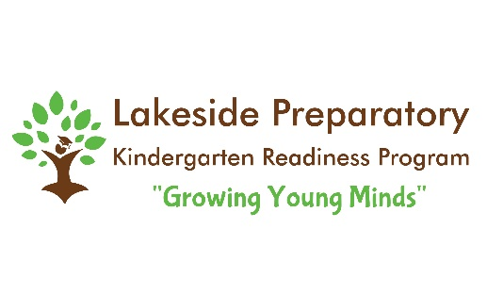
Summer Camps 2021
9:00-1:00
$130
117 Gilead Road
Huntersville, NC 28078

This camp is geared toward PreK-5th Grade.
Children will enjoy four days of fun and engaging learning
activities, experiments and projects. Each camp will have daily themes including science experiments, cooking activities, physical fitness, obstacle courses and art projects. Snack will be provided. Please send a lunchbox, beach towel and water bottle.

A $30 non refundable deposit is due to reserve your spot. Venmo @ Julie-Belk or cash is also accepted. You may also pay in full at any time. The full balance is due April 15th. There is a sibling discount of $10 off the first and $20 off the second. Please let me know if you have any questions.

Julie Belk
704-577-0399
info@lakesidekprep.com
You can also visit
www.lakesidekprep.com for more info. about Lakeside Prep

