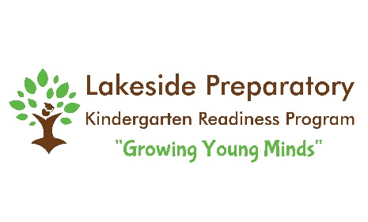
Photo Release

I agree that any photos and/or videos taken of my children, myself or family may be used by Lakeside Preparatory at its sole discretion. This includes, but is not limited to, social media, texting updates, print advertising, art/class activities, online marketing, newsletters, website photos and promotional material.

______________________________________________ _______________
Parent Signature Date

